Limited space

Limit fuctions? Forward,backward, side move, break

Prevent accident pressing

Must be able to be function in current setup

Foot Switch

[https://www.quietpc.com/images/products/usb-footswitch-3-large.jpg\](https://www.quietpc.com/images/products/usb-footswitch-3-large.jpg%5C)

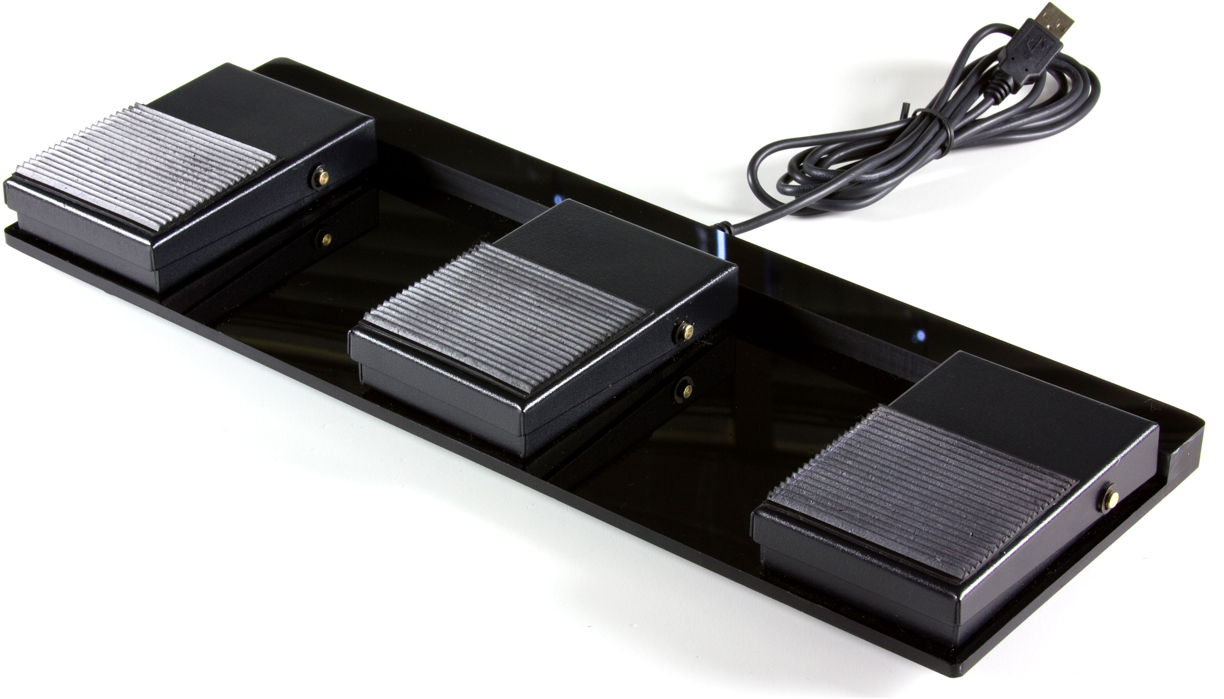

<https://www.amazon.co.uk/DecentGadget%C2%AE-Control-Keyboard-Action-Fu%C3%9Fpedal/dp/B00O055QB4/ref=pd_sbs_107_1?_encoding=UTF8&psc=1&refRID=VFGKZM1MVCP02JAE8FFT>

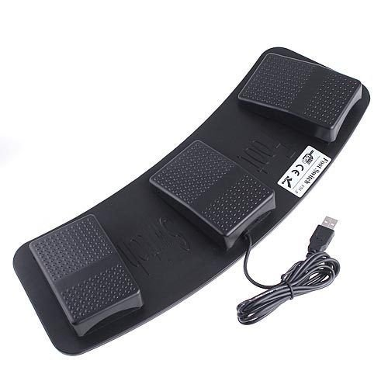

http://w3.siemens.com/mcms/industrial-controls/en/commanding-devices-signaling/foot-switch/pages/default.aspx

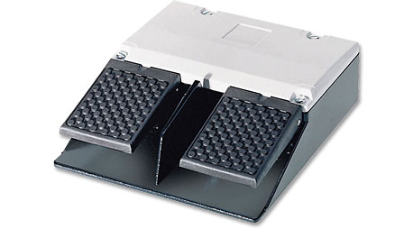

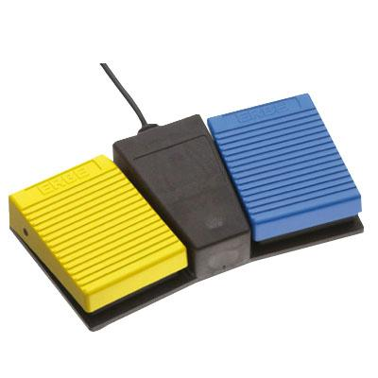

<https://www.dewertokin.com/products/medical/operating-elements/foot-switch/>

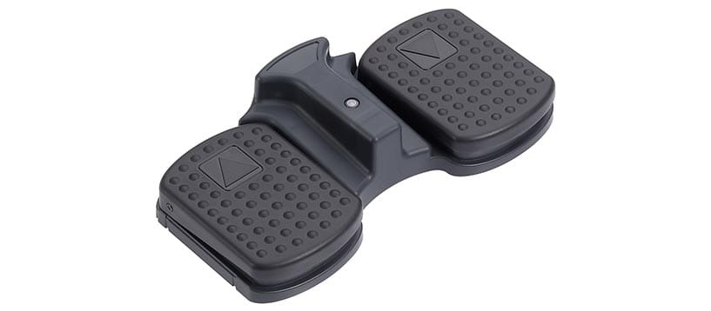

<https://www.amazon.co.uk/dp/B002MY6I7G/ref=psdc_949408031_t2_B00O055QB4>

